CST8804 Final Project
Your name: | Oluwatoni Oderinlo | Date: | Dec-12-2023

Fill the following table to reflect your address scheme.
Resource | Location | Function | Private network address | Public address
ACME INC, WAF | Azure Region 1 | Application Gateway | 10.1.28.0/24 | 131.107.1.1/24
ACME INC, LB | Azure Region 1 | Internet-facing load balancer | 10.1.28.0/24 | 131.107.1.2/24
ACME INC, Web services | Azure Region 1 | IIS + SQL+Storage+VMs | 10.1.28.0/24 | 131.107.1.3/24
ACME INC, jump box | Azure Region 2 | Virtual Machine | 10.2.28.0/24 | 131.107.1.4/24
ACME INC, Azure AD | Azure Region 2 | A cloud-based identity and access management service | 10.2.28.0/24 | 131.107.1.5/24
ACME INC, FW | Azure Region 2 | Azure Firewall | 10.2.28.0/24 | 131.107.1.6./24.
ACME INC HQ | On-premises | ACME INC HQ Inside network | 192.168.1.0/24 | NA
ACME INC HQ ASA Firewall – non MPLS interface | On-premises | ACME INC HQ ASA connection to ACME INC network | 192.168.50.254/24 | NA
ACME INC HQ ASA Firewall - MPLS | On-premises | ACME INC HQ MPLS entry point | 172.3.28.1/30 | NA
ACME INC HQ Palo Alto Firewall - inside | On-premises | ACME INC traffic inspection* | 192.168.1.254/24 | NA
ACME INC HQ Palo Alto Firewall - outside | On-premises | ACME INC traffic inspection* | NA | 203.0.113.20
ACME INC HQ Palo Alto Firewall - dmz | On-premises | ACME INC traffic inspection* | 192.168.50.10/24 | NA
ACME INC Branch Office | On-premises | ACME INC Branch Office inside network | 172.2.28.0/24
ACME INC Branch Office ASA Firewall-inside | On-premises | Traffic inspection* | 172.2.28.254/24
ACME INC Branch Office ASA Firewall-outside | On-premises | ACME INC MPLS connection | 172.3.28.2/30 | NA
ACME MPLS network | On-premises | ACPM MPLS network | 172.3.28.0/30

Submit a separate Visio document depicting network design and employed network security devices. Add data flows of interface to show data path.

Fill the following table to reflect data flows of interest.
Source | Location1 | Destination | Location2 | Application*
192.168.1.0/24 | ACME INC HQ | 10.1.28.0/24 | Azure Region 1 | HTTPS and SSH
192.168.1.0/24 | ACME INC HQ | 10.2.28.0/24 | Azure Region 2 | HTTPS and SSH
192.168.1.0/24 | ACME INC HQ | 172.2.28.0/24 | ACME INC  Branch Office | HTTPS and SSH
172.2.28.0/24 | ACME INC  Branch Office | 10.1.28.0/24 | Azure Region 1 | HTTPS and SSH
172.2.28.0/24 | ACME INC  Branch Office | 10.2.28.0/24 | Azure Region 2 | HTTPS and SSH
172.2.28.0/24 | ACME INC  Branch Office | 192.168.1.0/24 | ACME INC HQ | HTTPS and SSH
192.168.1.0/24 | ACME INC HQ | Any | Public network | IP, HTTPS and SSH
172.2.28.0/24 | ACME INC  Branch Office | Any | Public network | IP, HTTPS and SSH

If a task call for the SSs and explanations creates as many tables as you need using following format:

Indicate Part 2, Steps 1
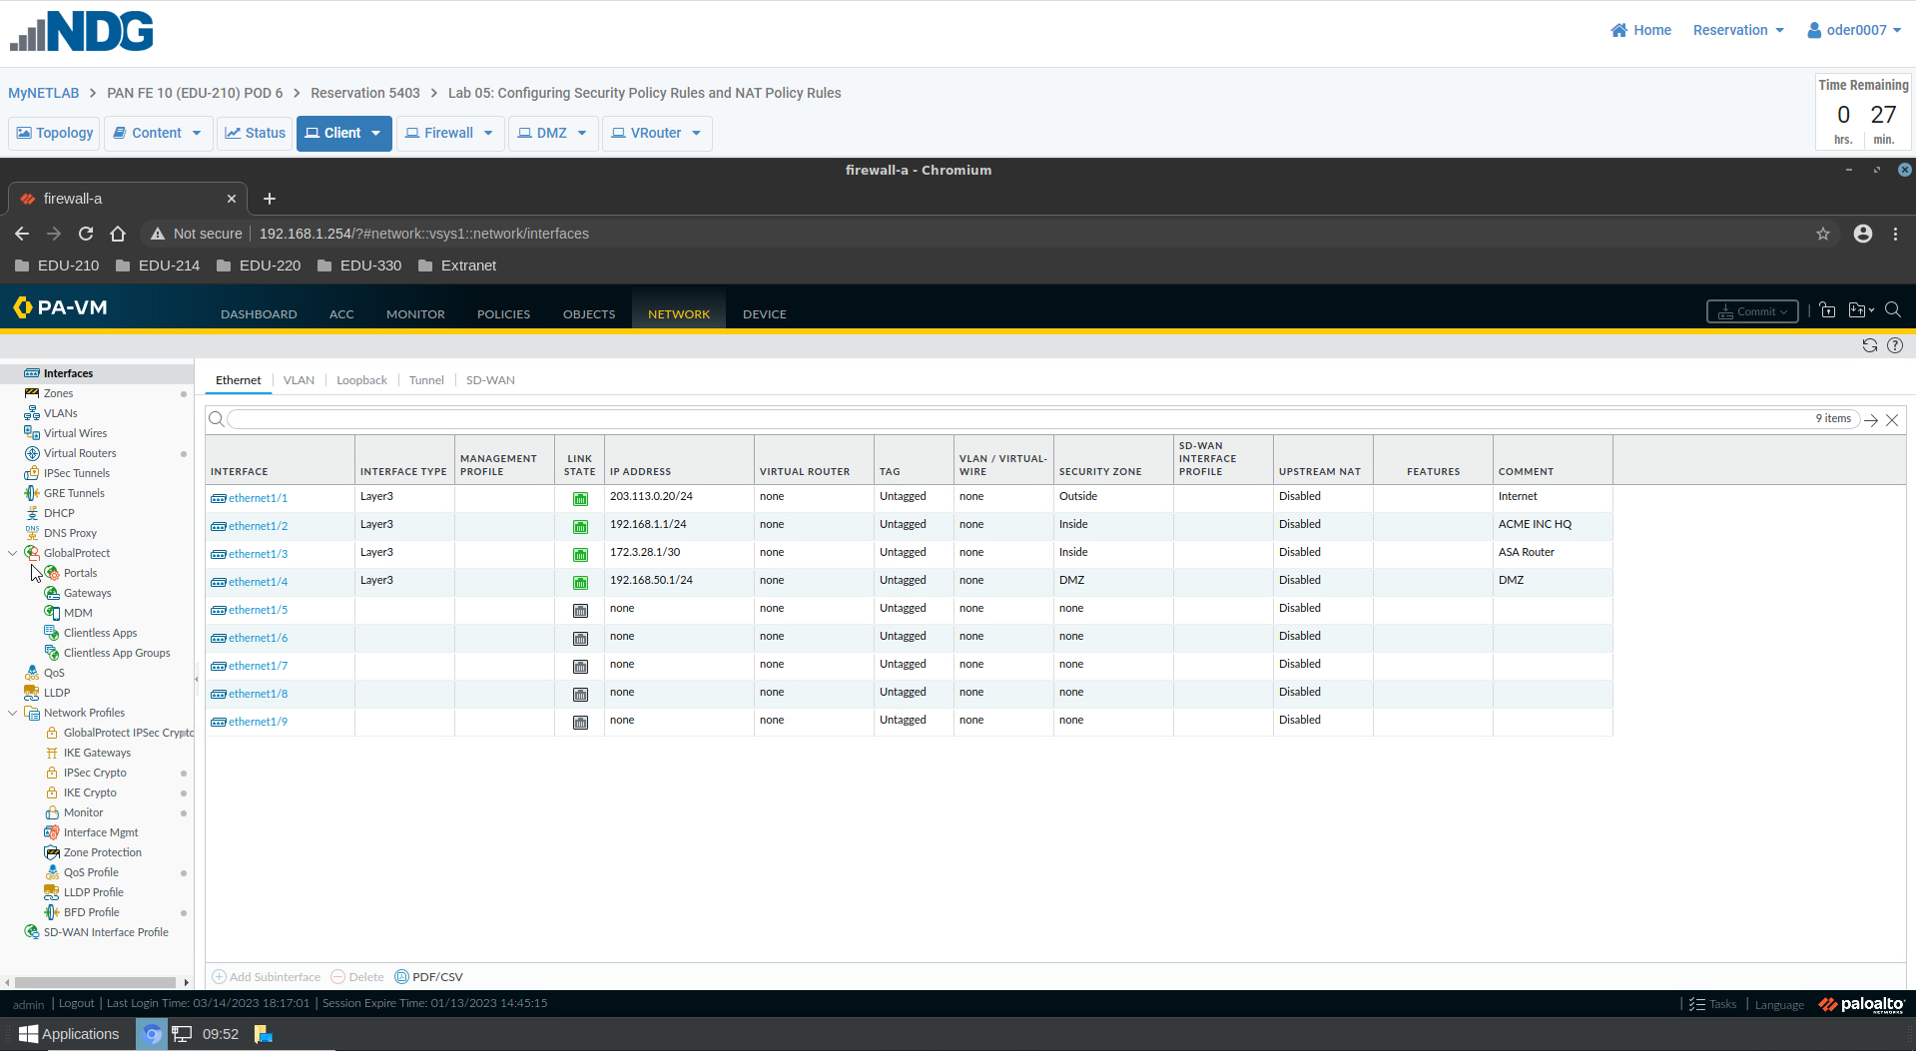
Explanation | In blue are the custom ethernet created as per lab requirements

Indicate Part 2, Steps 2
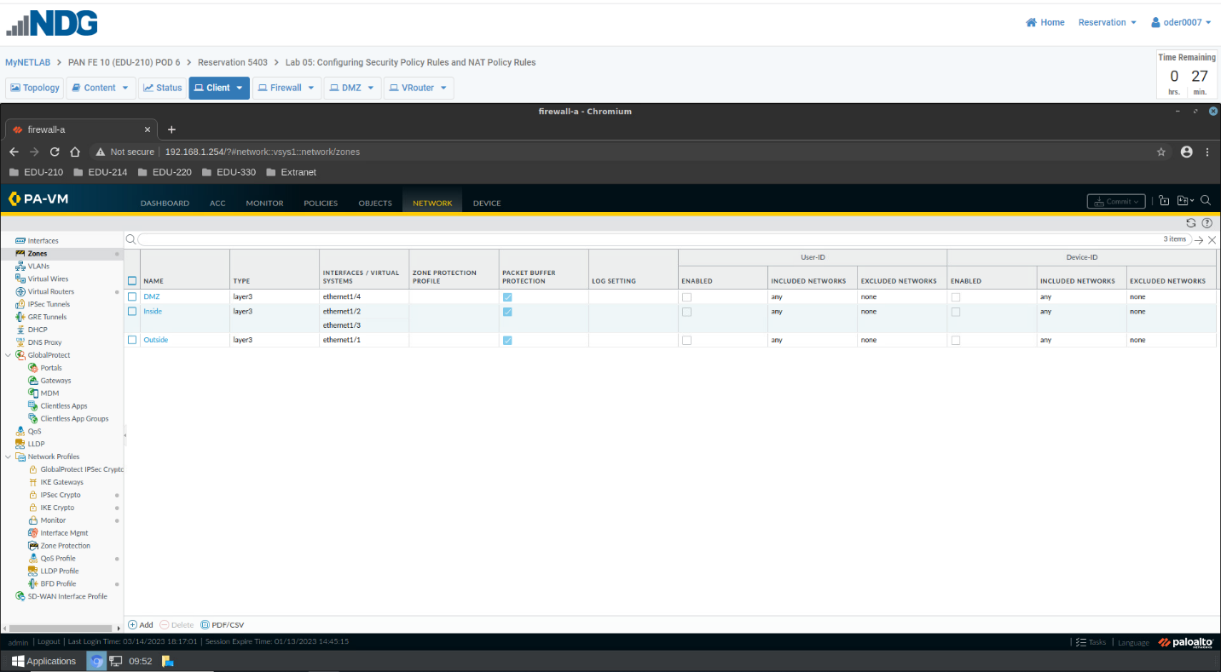

Explanation | In blue are the created zones

Indicate Part 3, Steps 1
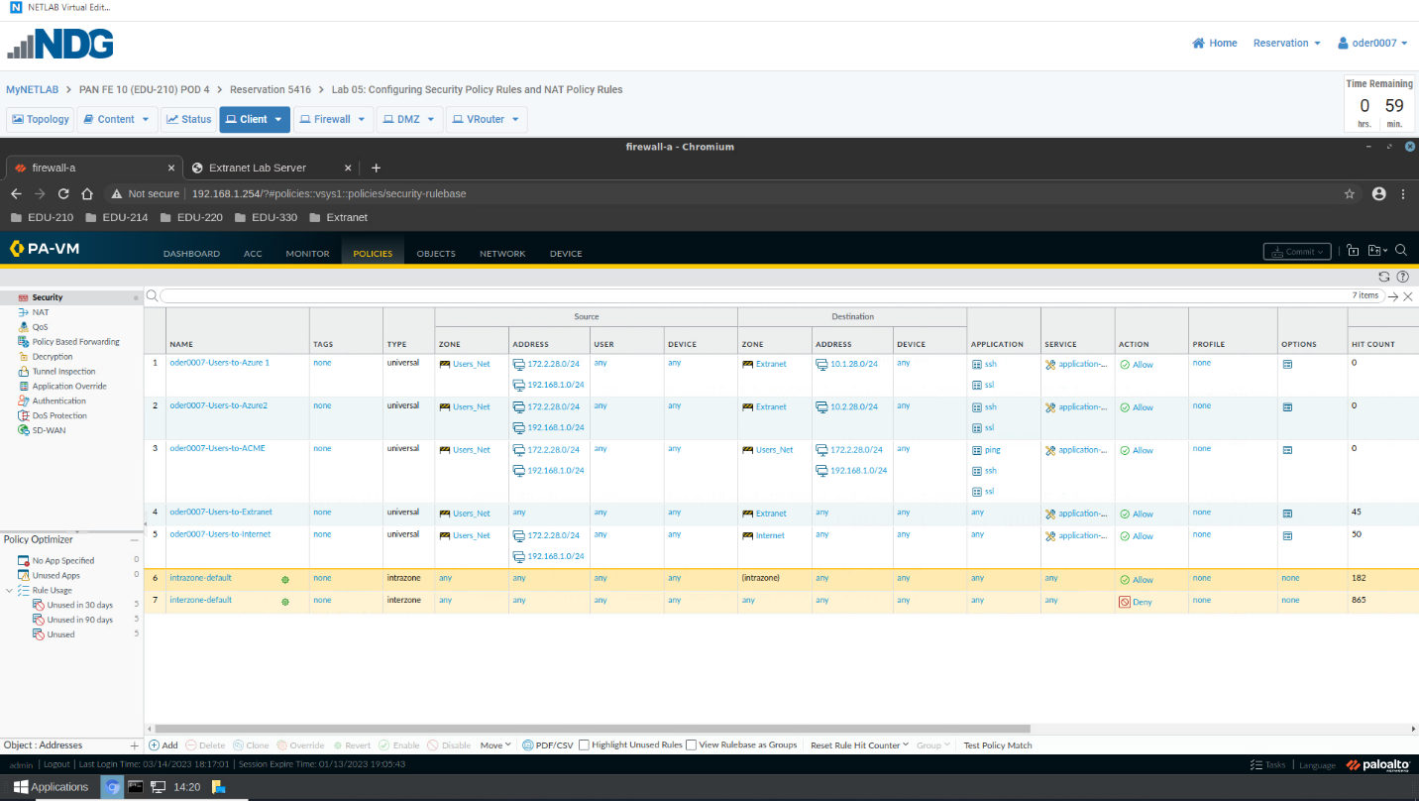
Explanation | In blue is the created security policy that will allow ssh, html and ping applications to allow pinging of 192.168.50.80 to go through.  In red is the Hit count column of the security policies created.  No  The other policies that will be made later in the project were Users-to-internet, Users-to-extranet, Users-to Azure 1and Users-to Azure 2.  The position of the rule in the security policy table is 3.  Any other created security policy rule created will either go from 1-2 or 4-5 as per the screenshot above.  Yes, by changing the default port for Firefox to 8080.

Indicate Part 3, Steps 2
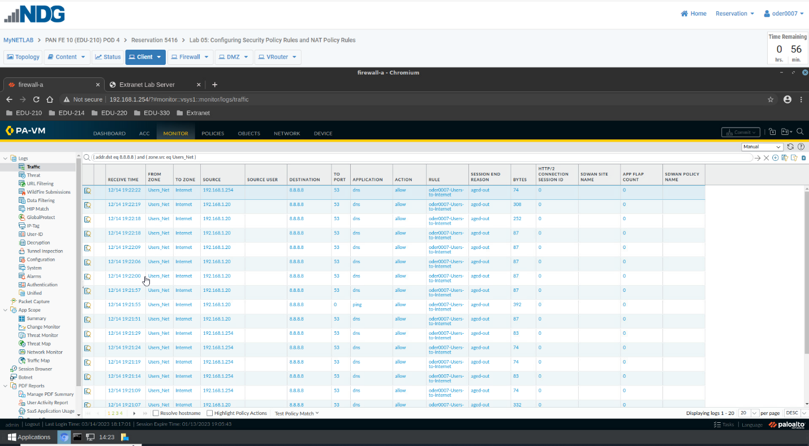
Explanation | In blue shows the traffic that goes through (addr. dest eq 8.8.8.8) and (zone.src eq Users_Net) in the Monitoring>Log section.  No.  Because that specific traffic isn’t allowed on the network

Indicate Part 3, Steps 3
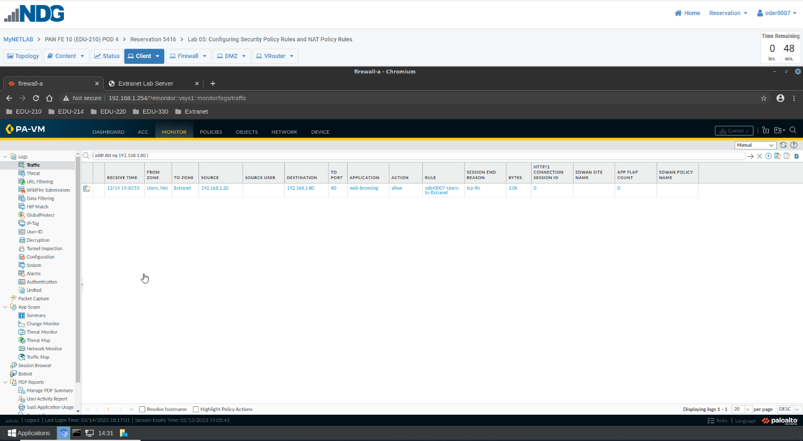
Explanation | In blue shows the traffic that goes through (addr. dest eq 192.168.1.80) in the Monitoring>Log section.  The rule name is oder0007-Users-to-Extranet and Yes.  Inside_Nets_to_Internet and Dest_NAT_To_Webserver  One that enables us to have access to the Internet and one that enables us to have access to the destination NAT of a Webserver.  No.

Indicate Part 3, Steps 4
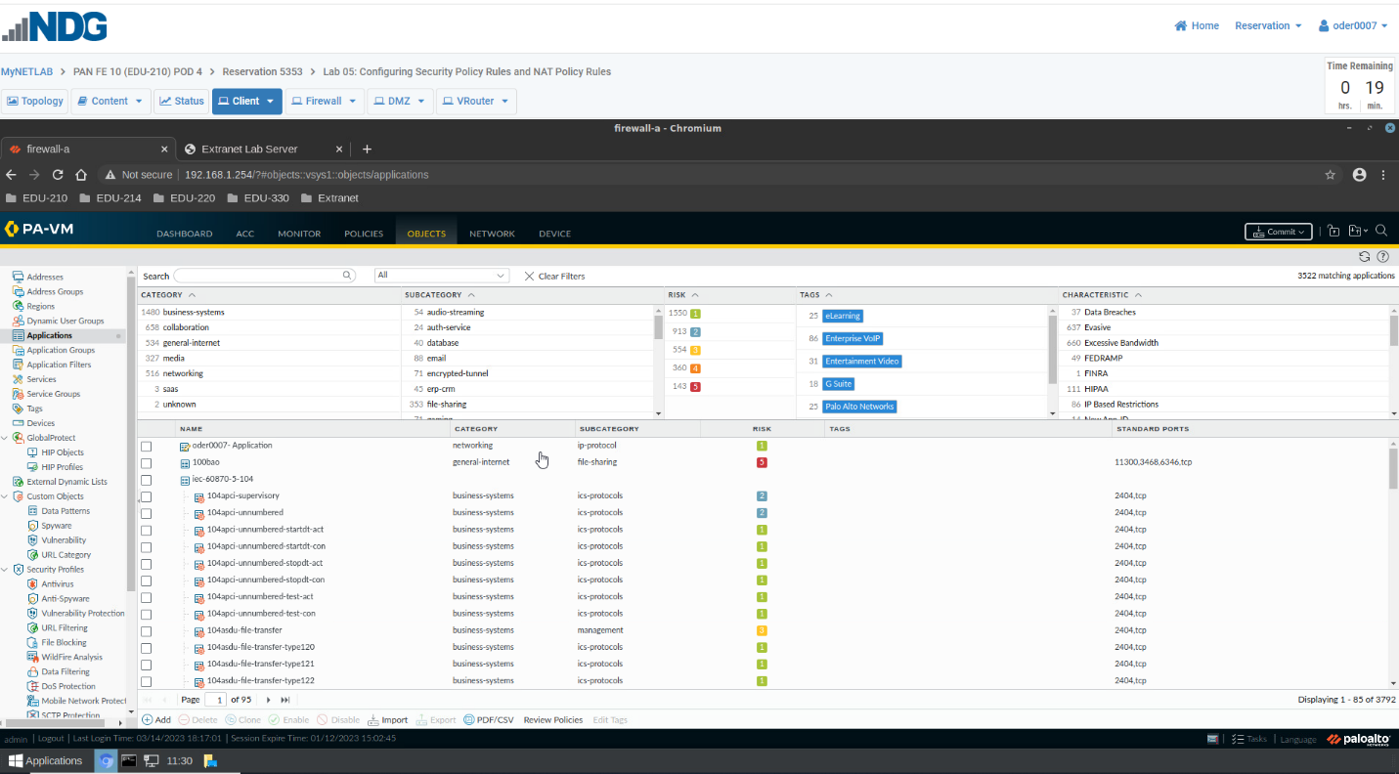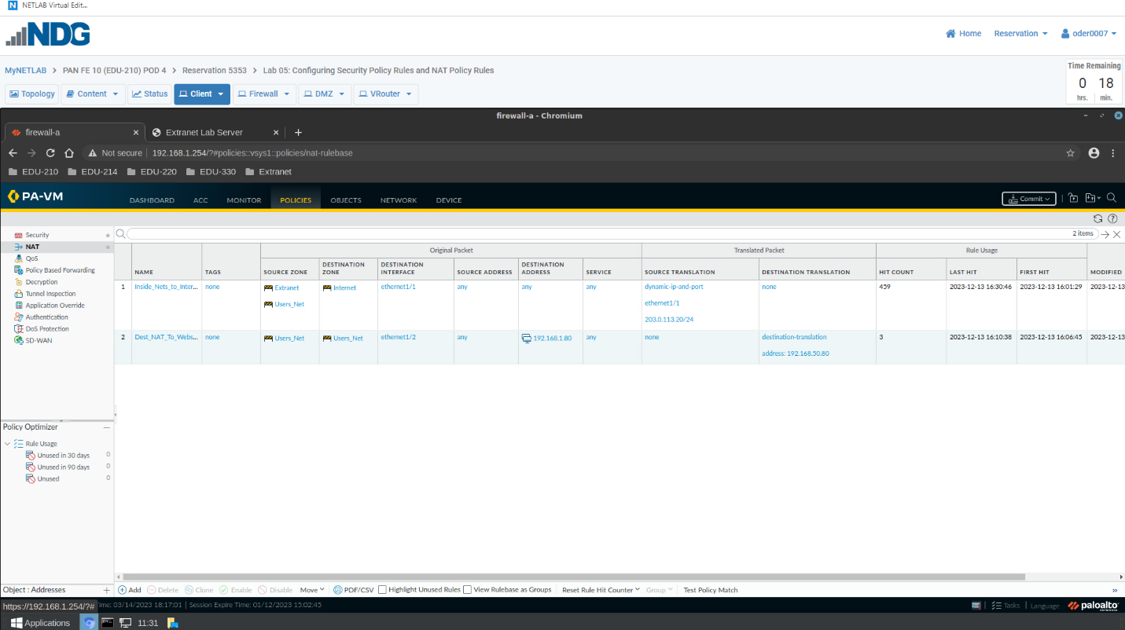

Explanation | In blue shows the configured object created in Applications to match the final project requirements.  In red shows the configured security policies that were created.  In yellow shows the configured NAT that was created.  No additional NAT was created

